Project Report

Our team consists of the following 5 members:

1. Alixa Bahena
2. Jonathan Martin
3. Yuntian Zhang
4. Nhu Nguyen
5. Javier Rivera

## team organization

##### Our team consists of a total of 5 members. Since each of us have different programming skills and backgrounds we decided it would be best to follow a democratic team approach. Since the basic concept of this team approach relies in egoless programming we thought this method might better fit our team’s diverse skill set and allow for each of us to contribute better to the development of the product. One key aspect of this team model is the procedure taken during the decision making process. As a democratic team each member was able to voice his/her opinion regarding the decisions which would be taken in order to solve a problem or fulfill client demands.

UML Diagrams Used:

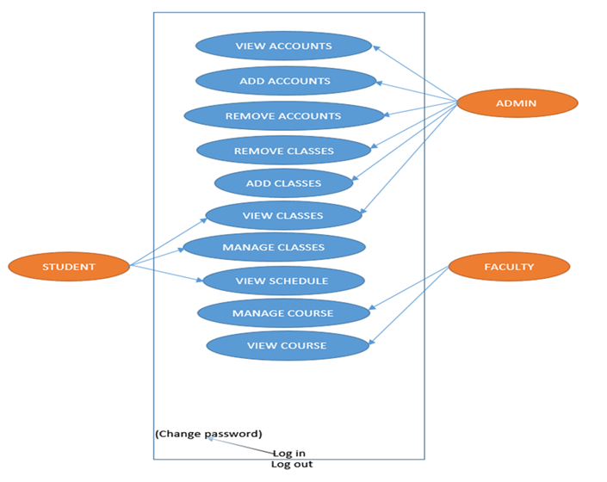

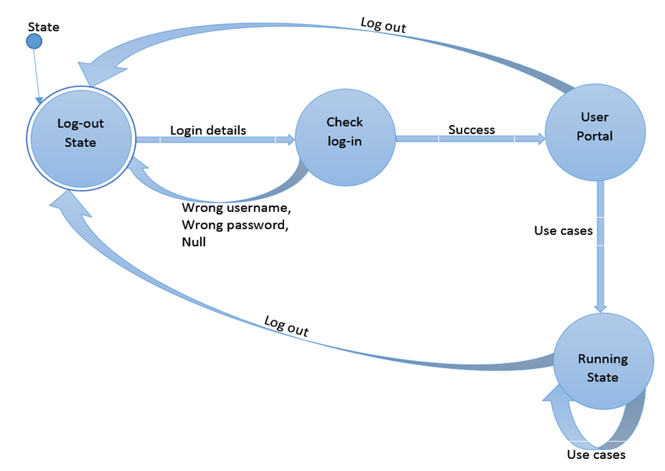

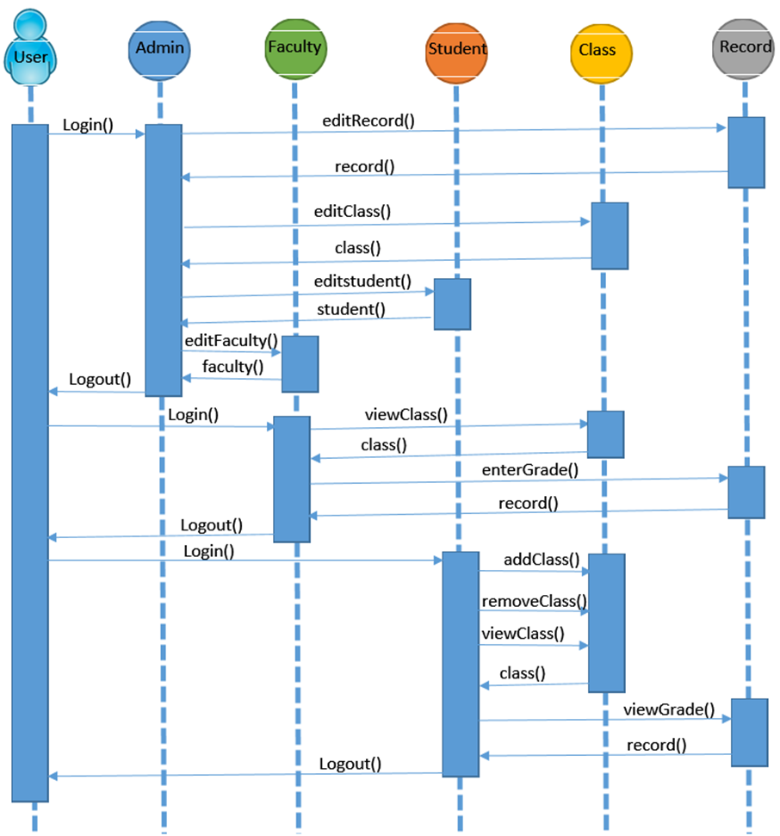

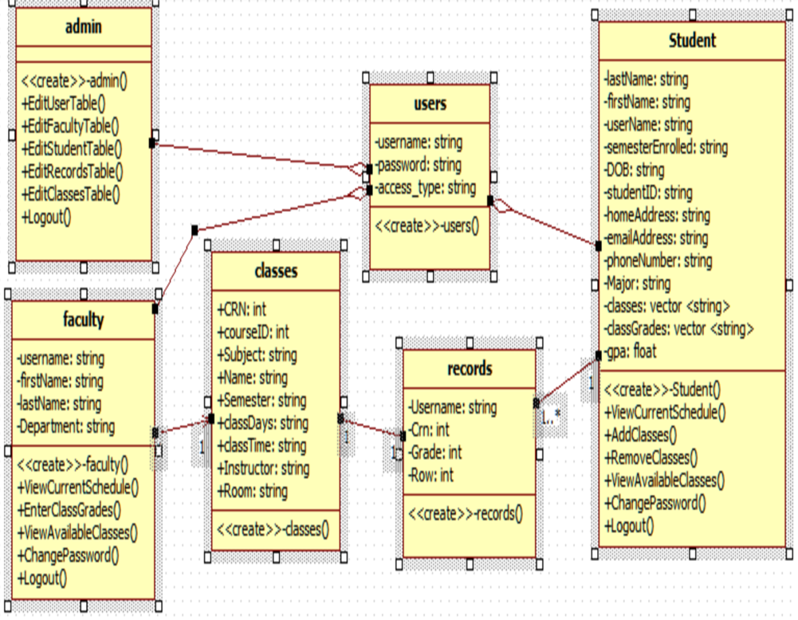

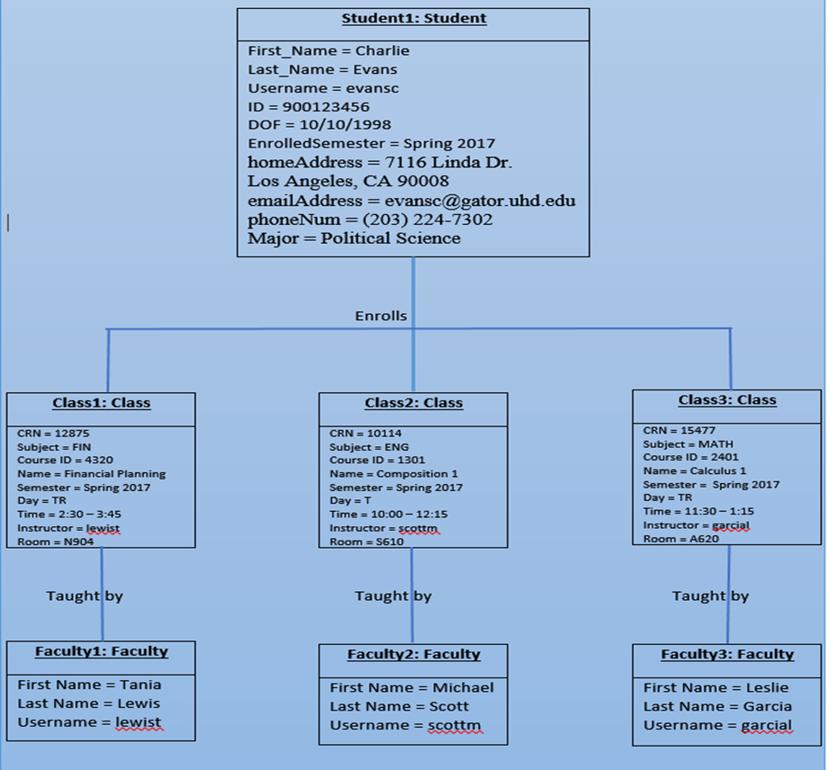

**NOTE: More detailed Information regarding these diagrams can be found in our technical design document.**